Artificial Intelligence & Machine Learning Intern
Internship Report

M.Sc. - Data Science and Analytics
Kaushal Sahu
24MSRDS076
SEMESTER IV
Department of Data Analytics and Mathematical Sciences

Internal Guide

Dr. J. Venkata Ramana Raju
Assistant Professor
Department of Data Analytics & Mathematical Sciences

External Guide / Organizational Mentor

Mr. Prabhat Jha
Technical Lead
Innovate

April 2026

CERTIFICATE

This is to certify that the student Mr. Kaushal Sahu from JAIN (Deemed-to-be University) has joined an internship at Innovate by HEXAIND, and this report is based on the result of the work carried out during this internship under the guidance and supervision of Dr. J. Venkata Ramana Raju and Mr. Prabhat Jha.

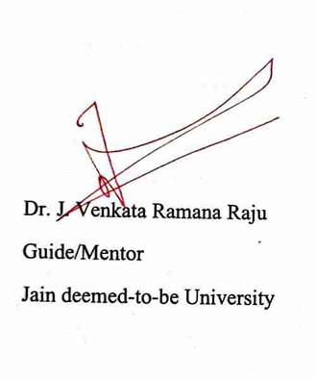

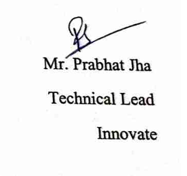

Dr. J. Venkata Ramana Raju | Mr. Prabhat Jha
Guide/Mentor | Technical Lead
Jain deemed-to-be University | Innovate

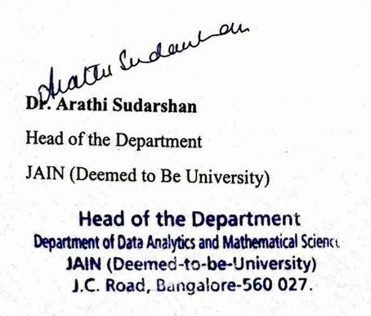

Dr. Arathi Sudarshan

Head of the Department

JAIN (Deemed to Be University)

ACKNOWLEDGEMENT

I express my sincere gratitude to my internal guide Dr. J. Venkata Ramana Raju and organizational mentor Mr. Prabhat Jha, for the invaluable guidance, continuous encouragement, and constructive suggestions throughout the course of this project. Their expertise, patience, and insightful feedback greatly contributed to the successful completion of this work.
I acknowledge the support provided by Dr. Asha Rajiv, Director, School of Sciences and the institution for granting support required for this internship. I extend my heartfelt thanks to the Head of the Department, Dr. Arathi Sudarshan, and the faculty members of the Department of Data Analytics & Mathematical Sciences, JAIN (Deemed-to-be University), for providing the necessary academic environment, resources, and support.
I am deeply thankful to the review committee for their valuable inputs and timely evaluations that helped improve the quality of this work. I would like to thank my friends and classmates for their cooperation, discussions, and moral support during this period.
Finally, I express my deepest gratitude to my parents and family members for their constant encouragement, understanding, and unwavering support throughout my academic journey.
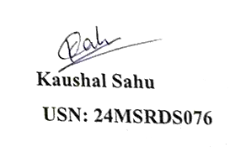

Kaushal Sahu
USN: 24MSRDS076

OFFER LETTER

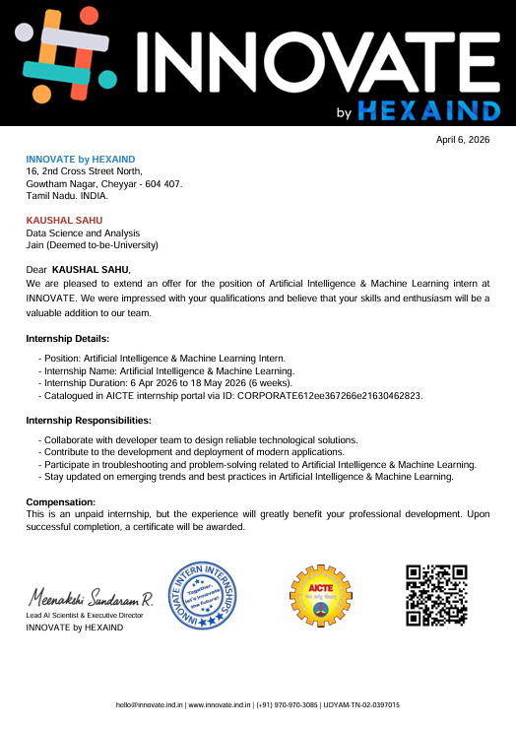

ABSTRACT

This report provides a comprehensive overview of the six-week internship undertaken at Innovate by HEXAIND, focusing on the domain of Artificial Intelligence (AI) and Machine Learning (ML). The internship emphasized practical exposure to real-world applications, particularly in the field of computer vision and deep learning.

The central project, titled “Precise Object Segmentation using Mask R-CNN”, aimed to develop a deep learning-based system capable of identifying and segmenting objects at a pixel level. Unlike traditional object detection methods that provide bounding boxes, this approach enhances precision by generating segmentation masks for each object.

During the internship, various tools and technologies such as Python, TensorFlow/PyTorch, and OpenCV were extensively used. The experience significantly strengthened both theoretical understanding and practical skills in model development, data preprocessing, and performance evaluation.

COMPANY PROFILE

Overview of the Organization

Innovate by HEXAIND is a technology-focused organization dedicated to developing innovative solutions in Artificial Intelligence, Machine Learning, and software engineering. The organization aims to leverage cutting-edge technologies to solve real-world problems efficiently.

Vision and Mission
- Vision:
To contribute to technological advancement by building intelligent and scalable AI-driven systems. Mission:
To design and deploy innovative solutions that enhance productivity, efficiency, and decision-making across industries.

Services Offered
Innovate by HEXAIND offers a range of technology-driven services centered around software development, Artificial Intelligence, and data-based solutions. The organization is involved in designing and developing intelligent systems, implementing machine learning models, and working on data-driven applications across different domains.
The company also works on research-oriented projects that involve computer vision, predictive analytics, and automation. These services are aimed at solving practical problems and improving efficiency in various application areas such as healthcare, business analytics, and smart systems.
In addition to its core technical services, the organization provides internship opportunities where students can contribute to ongoing projects. These internships are integrated into the company’s workflow, allowing interns to gain exposure to real-time development processes, tools, and collaborative environments.

Organizational Structure
The company operates through well-defined teams:
- Research Team – Focuses on exploring new AI methodologies and innovations
- Development Team – Implements and deploys AI/ML models
- Project Management Team – Oversees execution and delivery
The AI/ML division plays a crucial role in developing intelligent systems, particularly in areas like computer vision, natural language processing, and predictive analytics.

Department of Internship
The internship was carried out in the Artificial Intelligence and Machine Learning (AI/ML) Department at Innovate by HEXAIND. This department plays a vital role in the organization by focusing on the development, implementation, and optimization of intelligent systems that can analyze data, learn patterns, and make predictions or decisions with minimal human intervention

JOB PROFILE

Role Description

During the internship, I worked as an Artificial Intelligence & Machine Learning Intern, where my primary responsibility was to understand and apply machine learning techniques in the field of computer vision. The internship focused on implementing and analyzing deep learning models for image-based tasks, particularly object detection and segmentation.

Key Responsibilities

Understanding the fundamentals of computer vision and deep learning models

Studying and analyzing the Mask R-CNN architecture for object segmentation

Working with image datasets for object detection and segmentation tasks

Performing data preprocessing, including image resizing and normalization

Evaluating model performance using metrics such as Intersection over Union (IoU) and accuracy

Exploring real-world applications of object segmentation in domains like healthcare and autonomous systems

Assisting in understanding model workflows including feature extraction and region-based detection

Tools and Technologies Used
- Programming Language: Python
- Framework: TensorFlow / PyTorch
- Libraries: OpenCV, Scikit-learn
- Concepts:
  - Computer Vision
  - Deep Learning
  - Object Detection & Segmentation
  - Mask R-CNN
  - Image Preprocessing
  - Model Evaluation Metrics (IoU, Accuracy)

Learning Objectives
The main objectives of the internship were:
- To gain hands-on experience in Artificial Intelligence and Machine Learning
- To understand the working of deep learning models in computer vision
- To learn how image data is processed and used for object detection and segmentation
- To build a strong foundation in AI model workflows and real-world applications

Weekly Reports & Learning Summary
Week 1: Introduction and Understanding Basics

During the first week of the internship, I was introduced to the organization’s workflow and the fundamentals of Artificial Intelligence and Machine Learning. I focused on understanding core concepts such as AI, ML, and Deep Learning, along with their real-world applications.

In addition, I explored the basics of Python programming and its importance in AI/ML development. I worked with essential libraries like NumPy and pandas to understand data handling and analysis. This formed the foundation required for implementing machine learning models.

Alongside the learning modules, I studied the project titled Face Recognition-Based Attendance System. I understood the overall system workflow, including data collection, preprocessing, model training, and deployment using Flask. This week helped in building a strong theoretical and practical base for further development.
Key Learnings
- Basics of AI & Computer Vision
- Difference between Detection vs Segmentation
- Introduction to CNN
- Understanding real-world applications

Overall Learning Summary
During the first week of the internship, the key learning was building a strong foundation in Artificial Intelligence, Machine Learning, and Python programming. I developed an understanding of how AI systems learn from data and how these concepts are applied in real-world scenarios.
I also gained practical exposure to Python and essential libraries, which helped me understand how data is processed and prepared for machine learning models. This was important for connecting theoretical knowledge with practical implementation.
Additionally, I developed a clear understanding of the project requirements, particularly how face recognition systems work and how different components such as image processing, model training, and web integration come together to form a complete system.
.

INTRODUCTION

In today’s rapidly evolving technological landscape, Artificial Intelligence and Machine Learning play a crucial role in enabling intelligent systems across various industries. From automation to predictive analytics, these technologies are transforming the way data is processed and utilized.

Innovate by HEXAIND operates in this domain, focusing on developing innovative solutions using modern technologies such as AI, ML, and data science. The organization emphasizes research, development, and real-world implementation of advanced technological systems.

The purpose of this internship was to bridge the gap between theoretical knowledge and practical application. The internship aimed to provide exposure to real-world problem-solving using machine learning models, particularly in the field of computer vision.

The scope of work included understanding object detection and segmentation techniques, studying Mask R-CNN architecture, and applying it to analyze images for precise object segmentation. The internship also involved learning about workflows used in AI projects, including data handling, model evaluation, and optimization.

ORGANIZATION PROFILE

Innovate by HEXAIND is a technology-driven organization that focuses on developing innovative solutions in domains such as Artificial Intelligence, Machine Learning, and software development. The company works on building intelligent systems that address real-world challenges through data-driven approaches.

The vision of the organization is to contribute to technological advancement by developing impactful and scalable solutions. Its mission is to design efficient systems while fostering innovation and continuous learning within the organization.

The company follows a structured organizational framework consisting of leadership, development teams, research units, and project management teams. Each team plays a vital role in ensuring smooth execution of projects and maintaining quality standards.

During the internship, the work was carried out within the Artificial Intelligence and Machine Learning domain. This department is responsible for developing intelligent models, conducting research, and implementing data-driven solutions. It plays a crucial role in the organization by driving innovation and enabling the development of advanced applications.

LITERATURE REVIEW

4.1 INTRODUCTION TO COMPUTER VISION:

Computer Vision is a field of Artificial Intelligence that enables machines to interpret and understand visual data such as images and videos. It plays a crucial role in applications like object detection, facial recognition, medical imaging, and autonomous driving.

In modern systems, computer vision models are designed to extract meaningful information from visual inputs. These models help automate tasks that traditionally required human vision, improving efficiency and accuracy across industries.

4.2 DEEP LEARNING IN COMPUTER VISION:

Deep Learning is a subset of machine learning that uses neural networks with multiple layers to analyze complex data. In computer vision, deep learning models are used to identify patterns, features, and objects within images.

These models automatically learn features from data, eliminating the need for manual feature extraction. This makes them highly effective for tasks such as image classification, object detection, and segmentation.

4.3 CONVOLUTIONAL NEURAL NETWORKS (CNNs):

Convolutional Neural Networks (CNNs) are specialized deep learning models designed for processing image data. They use convolutional layers to extract important features such as edges, textures, and shapes from images.

CNNs consist of multiple layers including convolutional layers, pooling layers, and fully connected layers. These layers work together to identify patterns and make predictions based on visual data.

CNNs form the foundation for advanced models like object detection and segmentation frameworks.

4.4 OBJECT DETECTION:

Object Detection is a computer vision technique used to identify and locate objects within an image. It not only classifies objects but also provides bounding boxes around them.

Popular object detection models include Faster R-CNN, YOLO, and SSD. These models are widely used in applications such as surveillance systems, traffic monitoring, and retail analytics.

4.5 OBJECT SEGMENTATION:

Object Segmentation is an advanced technique that goes beyond object detection by identifying the exact shape and boundaries of objects at the pixel level. It provides more detailed information compared to bounding boxes.

There are two main types:

Semantic Segmentation: Classifies each pixel into a category

Instance Segmentation: Identifies individual objects separately

This technique is useful in applications like medical imaging and autonomous vehicles.

METHADOLOGY

5.4 WORKFLOW

5.4.1 Understanding Core Concepts

The first stage of the internship focused on building a foundational understanding of Artificial Intelligence, Machine Learning, and Deep Learning. This included learning their definitions, differences, and relationships.

Concepts such as types of Artificial Intelligence (Narrow AI, General AI) and types of Machine Learning (Supervised, Unsupervised, Reinforcement Learning) were studied in detail.

5.4.2 Exploring Real-World Applications

In this stage, various real-world applications of AI and ML were explored across industries such as healthcare, finance, transportation, and education.

This helped in understanding how theoretical concepts are applied in solving real-world problems.

5.4.3 Learning Through Study Materials and Lectures

Multiple learning resources such as lecture notes, research papers, and video lectures were referred to in order to strengthen conceptual understanding.

This stage focused on gaining clarity on key topics and building a strong theoretical base.

5.4.4 Basic Hands-on Implementation

A simple machine learning model (Linear Regression) was implemented using Python and Scikit-learn to understand how models learn from data.

This included:

Providing input-output data

Training the model

Making predictions

This step provided practical exposure to the working of machine learning algorithms.

5.4.5 Understanding Machine Learning Workflow
The final stage involved understanding the general workflow of a machine learning system, including:
- Data input
- Model training
- Prediction
- Evaluation
This helped in building a clear understanding of how AI models function in real-world scenarios.

5.5 WORKFLOW SUMMARY
- Learned fundamentals of AI, ML, and Deep Learning
- Studied types and applications of ML
- Referred to research materials and lectures
- Implemented a basic ML model using Python
- Understood overall machine learning workflow

RESULTS

6.1 OVERVIEW
The internship work resulted in a strong foundational understanding of Artificial Intelligence, Machine Learning, and Deep Learning concepts. The structured learning approach helped in developing clarity on how machine learning models function and how they are applied in real-world scenarios.
The combination of theoretical study and basic practical implementation enabled a better understanding of the machine learning workflow. Each stage of the internship contributed to building conceptual knowledge and practical awareness.
.

6.2 CONCEPTUAL LEARNING OUTCOMES
The internship provided a clear understanding of the differences between Artificial Intelligence, Machine Learning, and Deep Learning. Concepts such as supervised, unsupervised, and reinforcement learning were explored in detail.
This helped in building a strong theoretical base required for understanding more advanced topics in AI and ML.
.

6.3 PRACTICAL IMPLEMENTATION RESULTS

A basic machine learning model using Linear Regression was implemented using Python and Scikit-learn. This demonstrated how models learn from data and make predictions.

The implementation helped in understanding:

How input data is used for training

How relationships between variables are learned

How predictions are generated

6.4 APPLICATION UNDERSTANDING RESULTS
Various real-world applications of AI and ML were studied, including their use in healthcare, finance, and transportation.
This provided insights into how machine learning models are used in solving real-world problems and improving efficiency across industries.

6.5 DELIVERABLES
The key deliverables of the internship include:
- Conceptual understanding of AI, ML, and Deep Learning
- Basic implementation of a machine learning model
- Study of real-world AI applications
- Documentation of learning and workflow

DISCUSSIONS

7.1 INTERPRETATION OF RESULTS
The results indicate that building a strong foundation is essential for understanding advanced machine learning concepts. It was observed that theoretical knowledge plays a crucial role in interpreting how models function.
The practical implementation of a simple model helped in connecting theory with application. This highlighted the importance of learning both conceptual and practical aspects together.

7.2 CHALLENGES FACED
Several challenges were encountered during the internship:
- Understanding differences between AI, ML, and Deep Learning
- Grasping machine learning concepts at an initial stage
- Interpreting how models learn from data
- Connecting theory with practical implementation

7.3 APPROACHES TAKEN
The challenges were addressed using the following approach:
- Referring to multiple learning resources and lectures
- Breaking down concepts into simpler parts
- Practicing basic implementation using Python
- Revising concepts regularly for better understanding

7.4 SKILLS AND KNOWLEDGE GAINED
The internship contributed to the development of key skills such as:
- Understanding of AI, ML, and Deep Learning fundamentals
- Knowledge of types of machine learning
- Basic experience with Python and Scikit-learn
- Improved analytical thinking and problem-solving skills
- Awareness of real-world AI applications

CONCLUSION
The internship at Innovate by HEXAIND provided a valuable introduction to the field of Artificial Intelligence and Machine Learning. It helped in building a strong conceptual foundation and understanding the importance of these technologies in modern applications.
Through the study of key concepts and basic implementation, the internship successfully bridged the gap between theoretical knowledge and practical exposure. The experience enhanced technical understanding and prepared the foundation for exploring advanced topics in AI and ML.
Overall, the internship was a meaningful learning experience that contributed to both academic and professional development.

FUTURE SCOPE
The current work can be further enhanced by moving beyond foundational concepts to advanced machine learning and deep learning techniques.
Future improvements can include:
- Implementing advanced models such as CNNs and Mask R-CNN
- Working with real-world datasets for practical projects
- Exploring computer vision and deep learning applications
- Learning model training, optimization, and deployment
Additionally, gaining experience with advanced tools and frameworks will further strengthen practical knowledge and industry readiness.

REFERENCES
- Goodfellow, I., Bengio, Y., & Courville, A. (2016). Deep Learning. MIT Press.
- Géron, A. (2019). Hands-On Machine Learning with Scikit-Learn, Keras, and TensorFlow. O’Reilly Media.
- Scikit-learn Documentation. (n.d.). Retrieved from https://scikit-learn.org
- TensorFlow Documentation. (n.d.). Retrieved from https://www.tensorflow.org
- NPTEL. (n.d.). Introduction to Artificial Intelligence Lecture Notes.

APPENDIX
The appendix includes supporting materials related to the internship work.
The following documents are included:
- Internship Offer Letter
- Module learning materials and notes
- Screenshots of Python code implementation (Linear Regression)
- Sample outputs of model predictions
- Reference materials and lecture resources
These documents support the learning outcomes and validate the work carried out during the internship.

